
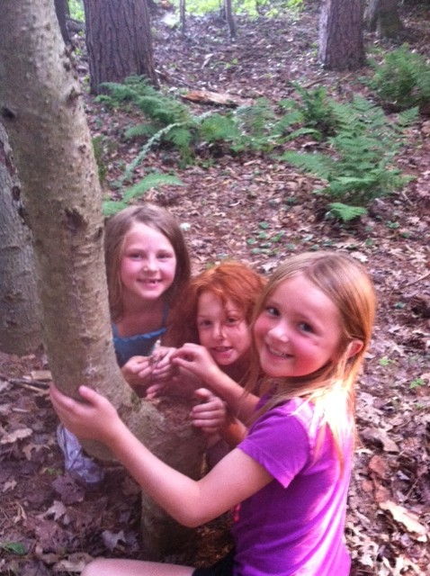
Vanderkamp is a sleep-away Summer Camp for kids ages 6-17 located on the North Shore of Oneida Lake! We simply work to help kids build confidence and character. Sure, we also have a private lake for swimming and canoeing, miles of trails for hiking and biking, an archery course, truly free range chickens who wander all over camp, the most affordable horseback program around over at North Riding, all sorts of sports, and just about the most outrageously fun activities anywhere. When kids come to Vanderkamp for a week, they leave “much more confident,” “with a bunch of new friends,” and “just happier.” Those are all quotes from kids or parents from camp last summer. We’re using a cutting edge approach grounded in child development theory to give kids the most fun and meaningful experience possible!

We pride ourselves on being the safest place from teasing and bullying on the planet!

Email us at vkcenter@vk.org, go to vk.org and click on the “Summer
Camp” button for more information, or call 315-675-3651 today!



